Expert Lecture
Academic Year 2023-2024
S.No | Name of the Resource person | Designation and organization | Date organized | Topic covered
1 | Shri. ANSP Shastry Garu, | Retd Scientist, Bureau of Indian Standards | 6.10.2023(9.00AM to 2.30PM) | Expert lecture on " Indian standards"(World standards Day Celebrations)-2023
1 | Smt. Ch Vidisha Reddy, | Scientist-B, Asst Director, BIS. | 6.10.2023(9.00AM to 2.30PM)
1 | Shri. Abhisai Etta | Standards Promotion Officer, Hyderabad Branch | 6.10.2023(9.00AM to 2.30PM)
2 | B. Santhosh | Manager, Canter CADD, ECIL | 4.10.2023(2.00PM to 3.30PM) | Expert lecture on "Awareness on Civil Engineering Software"
3 | Er. Surya Prakash | Managing Director, Satyavani Projects and Constructions Pvt. Ltd.) | 15.09.2023(3.00PM to 4..30PM) | Civil Engineering Profession as a Challenging Career (Engineers Day)
4 | Er. N. Srinivas Rao | Engineer, Ultra Tech Cements | 09.09.2023(1.45PM to 2.45PM) | Expert lecture on “Next Generation Concrete”
5 | Er. C. Prashanth Kumar, | Deputy Geotechnical Engineer (Jacobs) | 20/10/2023, 02:00PM-03:30PM | Beyond the Degree: Navigating your career in Civil Engineering
5 | Er. M. Ambica | Project Engineer-II (Morrison Hershfield) | 20/10/2023, 02:00PM-03:30PM
6 | Ch Ravi Kumar | Senior Consultant, National Academy of Construction | 23.02.2024 | Emerging Technologies in Civil Engineering & Opertunities for Civil Engineering Graduates
7 | Ms. Priyadarshini | Ms. Priyadarshini, Councillor, CII- IGBC, Hyderabad | 12.03.2024 | Bridging the gap between Academia and Industry through Green Innovations

FACULTY DEVELOPMENT PROGRAM

Academic Year 2023-2024
S. No | Name of the Resource person | Designation and Organization | Date organized | Topic covered | Activity
1 | Dr. Srinivasarao N, Ph.D.  Scientist “E” and Scientist-in-Charge (Satellite Data Acquisition)  Indian National Centre for Ocean Information Services (INCOIS) |  | 29.01.2024 to 02.02.2024 | Green solutions for smart infrastructure development | Faculty Development Programe
1 | Dr. A.V. . Subba Rao, Consultant Genesys International Corporation Limited, Mumbai.  Consultant NEOM Project, Government of Saudi Arabia. Professor, Environmental Sciences, IST, JNTU-H. |  | 29.01.2024 to 02.02.2024 | Green solutions for smart infrastructure development | Faculty Development Programe
1 | Ms. Sri Rekha Mavulati, Senior Counsellor at the Indian Green Building Council (IGBC) of Confederation of Indian Industry (CII). |  | 29.01.2024 to 02.02.2024 | Green solutions for smart infrastructure development | Faculty Development Programe
1 | Mr. Prem Sai, Associate, Clean Energy, PwC, Hyderabad |  | 29.01.2024 to 02.02.2024 | Green solutions for smart infrastructure development | Faculty Development Programe
1 | Sanyukta Pande, Manager, Clean Energy, PwC, NCR, New Delhi |  | 29.01.2024 to 02.02.2024 | Green solutions for smart infrastructure development | Faculty Development Programe
1 | Anubha Ashtikar, Senior Associate, Clean Energy, PwC |  | 29.01.2024 to 02.02.2024 | Green solutions for smart infrastructure development | Faculty Development Programe

Training Programme

Academic Year 2023-2024
S. No | Name of the Resource person | Designation and Organization | Date organized | Topic covered | Activity
1 | 1. B. Santhosh, 2. S. Sai Mrudula, 3. B. Renuka | Trianer, CANTER CADD | 5.08. 2023, 12.08.2023, 19.08.2023, 09.09.2023, 15.09.2023, 16.09.2023, 04.10.2023, 11.10.2023, 21.10.2023 | “Career opportunities for students of Civil Engineering”  (Through extensive use of 'Sketchup' as a design tool) | Software Training Program
2 | 1. B. Santhosh, 2. S. Sai Mrudula, 3. B. Renuka | Trianer, CANTER CADD | 02/01/2024, 03/01/2024, 04/01/2024, 08/01/2024, 09/01/2024, 10/01/2024, 11/01/2024 | “Career opportunities for students of Civil Engineering”  (Through extensive use of 'Revit Arch.' as a design tool) | Software Training Program
3 | 1. B. Santhosh, 2. S. Sai Mrudula, 3. B. Renuka | Trianer, CANTER CADD | 12.02.2024, 13.02.2024, 14.02.2024, 15.02.2024, 19.02.2024, 20.02.2024 | “Career opportunities for students of Civil Engineering”  (Through extensive use of 'Revit Structures' as a design tool) | Software Training Program
4 | 1. B. Santhosh, 2. S. Sai Mrudula, 3. B. Renuka | Trianer, CANTER CADD | 02.03.2024, 09.03.2024, 16.03.2024, 30.03.2024, 02.03.2024, 02.03.2024, 02.03.2024 | “Career opportunities for students of Civil Engineering”  (Through extensive use of 'Sketch Up' as a design tool) | Software Training Program

Paper Publications
Academic Year : 2023-24
S No | Name of the faculty | Title of the paper | Journal | Year
1 | G Sampath Kumar | An experimental effect of bacillus concrete subtilis on conventional concrete | Journal of Fundamental & Comparative | 2024
2 | Goutham Vanam | Areal Interpolation approach for Covid-19 cases in India : A case of geospatial modelling | European Economic Letters | 2023
3 | V Navaneetha | Investigations of behaviour of concrete on adding crumb rubber | International Journal of Research | 2023
4 | D Varun Kumar | Study on high strength fiber reinforced geopolymer concrete | Material Science and Technology | 2023
5 | G Raju | A speed and delay study to improve the public transit system | Material Science and Technology | 2023
6 | P Supriya | A study on strength of a fibre reinforced concrete partially replaced with cement by dust and metakolin | Material Science and Technology | 2023
7 | Dr K Sri Lakshmi | Site suitability analysis for establishment of CETP at Chirala textile cluster (CTC) | Journal of Environmental Engineering and its scope | 2023
8 | Dr K Sri Lakshmi | Individual awareness on electronic waste and its management- an online survey | Journal of advanced research in Dynamical & control systems | 2023

- Student participation &achievements

Academic Year 2023-2024

S. No. | H. No. | Name | Event Name with Date | Place
 | 21R11A0101 | Uttej Vardan | 1-Day workshop on Tunneling on 03.01. 2024 | GITAM (Deemed to be University)
 | 21R11A0103 | B.N. Sai Santhosh | 1-Day workshop on Tunneling on 3rd Jan 2024 | GITAM (Deemed to be University)
 | 21R11A0105 | Bhanu Prakash | 1-Day workshop on Tunneling on 3rd Jan 2024 | GITAM (Deemed to be University)
 | 21R11A0114 | Sindhuja Pawar | 1-Day workshop on Tunneling on 3rd Jan 2024 | GITAM (Deemed to be University)
 | 21R11A0114 | Neela Komal | 1-Day workshop on Tunneling on 3rd Jan 2024 | GITAM (Deemed to be University)
 | 22R11A0101 | Edla Bharath Kumar | Career opportunities for students of Civil Engineering (Through extensive use of 'Sketch Up' as a design tool) | GCET
 | 22R11A0102 | Karreddula Sri Vani | Career opportunities for students of Civil Engineering (Through extensive use of 'Sketch Up' as a design tool) | GCET
 | 22R11A0103 | Nimishakavi Sai Moukthika | Career opportunities for students of Civil Engineering (Through extensive use of 'Sketch Up' as a design tool) | GCET
 | 23R15A0101 | Ankit Kumar Mehatha | Career opportunities for students of Civil Engineering (Through extensive use of 'Sketch Up' as a design tool) | GCET
 | 23R15A0102 | Annojigudem Niharika | Career opportunities for students of Civil Engineering (Through extensive use of 'Sketch Up' as a design tool) | GCET
 | 23R15A0103 | Banothu Siddu | Career opportunities for students of Civil Engineering (Through extensive use of 'Sketch Up' as a design tool) | GCET
 | 23R15A0104 | Bolleddu Azubha | Career opportunities for students of Civil Engineering (Through extensive use of 'Sketch Up' as a design tool) | GCET
 | 23R15A0105 | Cilasagaram Sai Pradeep Kumar | Career opportunities for students of Civil Engineering (Through extensive use of 'Sketch Up' as a design tool) | GCET
 | 23R15A0106 | Gourla Anand | Career opportunities for students of Civil Engineering (Through extensive use of 'Sketch Up' as a design tool) | GCET
 | 23R15A0107 | Jampala Ashwitha | Career opportunities for students of Civil Engineering (Through extensive use of 'Sketch Up' as a design tool) | GCET
 | 23R15A0108 | Kakarlamudi Adham | Career opportunities for students of Civil Engineering (Through extensive use of 'Sketch Up' as a design tool) | GCET
 | 23R15A0109 | Mohammad Hassain Qureshi | Career opportunities for students of Civil Engineering (Through extensive use of 'Sketch Up' as a design tool) | GCET
 | 23R15A0110 | P Sravani | Career opportunities for students of Civil Engineering (Through extensive use of 'Sketch Up' as a design tool) | GCET
 | 23R15A0111 | Pabbathi Samatha | Career opportunities for students of Civil Engineering (Through extensive use of 'Sketch Up' as a design tool) | GCET
 | 23R15A0112 | Pasunuri Manasa | Career opportunities for students of Civil Engineering (Through extensive use of 'Sketch Up' as a design tool) | GCET
 | 23R15A0113 | Sanga Nitin Sai | Career opportunities for students of Civil Engineering (Through extensive use of 'Sketch Up' as a design tool) | GCET
 | 23R15A0114 | Singaram Vyshnavi | Career opportunities for students of Civil Engineering (Through extensive use of 'Sketch Up' as a design tool) | GCET
 | 23R15A0115 | Sunkari Saicharan | Career opportunities for students of Civil Engineering (Through extensive use of 'Sketch Up' as a design tool) | GCET
 | 23R15A0116 | Syed Shaibaaz | Career opportunities for students of Civil Engineering (Through extensive use of 'Sketch Up' as a design tool) | GCET
 | 23R15A0117 | Thota Manasa | Career opportunities for students of Civil Engineering (Through extensive use of 'Sketch Up' as a design tool) | GCET
 | 23R15A0118 | Vemula Manoj Kumar | Career opportunities for students of Civil Engineering (Through extensive use of 'Sketch Up' as a design tool) | GCET
 | 20R11A0104 | Bathini Praveen | Career opportunities for students of Civil Engineering (Through extensive use of 'Revit Arch.' as a design tool) | GCET
 | 20R11A0120 | Guguloth Prashanth | Career opportunities for students of Civil Engineering (Through extensive use of 'Revit Arch.' as a design tool) | GCET
 | 20R11A0124 | Kallepu Bhanu Chandar | Career opportunities for students of Civil Engineering (Through extensive use of 'Revit Arch.' as a design tool) | GCET
 | 20R11A0125 | Kola Nikhil Kumar | Career opportunities for students of Civil Engineering (Through extensive use of 'Revit Arch.' as a design tool) | GCET
 | 20R11A0126 | Kurakula Archana | Career opportunities for students of Civil Engineering (Through extensive use of 'Revit Arch.' as a design tool) | GCET
 | 20R11A0127 | Lankadasari Kamal Kumar | Career opportunities for students of Civil Engineering (Through extensive use of 'Revit Arch.' as a design tool) | GCET
 | 20R11A0128 | Lokineni Rishi Deshmukh | Career opportunities for students of Civil Engineering (Through extensive use of 'Revit Arch.' as a design tool) | GCET
 | 20R11A0136 | Nidhanakavi Harika | Career opportunities for students of Civil Engineering (Through extensive use of 'Revit Arch.' as a design tool) | GCET
 | 20R11A0137 | Nimmala Kishore | Career opportunities for students of Civil Engineering (Through extensive use of 'Revit Arch.' as a design tool) | GCET
 | 20R11A0138 | P Santhosh Kumar | Career opportunities for students of Civil Engineering (Through extensive use of 'Revit Arch.' as a design tool) | GCET
 | 20R11A0139 | P Thirupathaiah | Career opportunities for students of Civil Engineering (Through extensive use of 'Revit Arch.' as a design tool) | GCET
 | 20R11A0140 | Palakurthi Brahmam | Career opportunities for students of Civil Engineering (Through extensive use of 'Revit Arch.' as a design tool) | GCET
 | 20R11A0145 | R Sai Chetan | Career opportunities for students of Civil Engineering (Through extensive use of 'Revit Arch.' as a design tool) | GCET
 | 20R11A0147 | Sai Karthik K | Career opportunities for students of Civil Engineering (Through extensive use of 'Revit Arch.' as a design tool) | GCET
 | 20R11A0148 | Sonnakula Sanjeev | Career opportunities for students of Civil Engineering (Through extensive use of 'Revit Arch.' as a design tool) | GCET
 | 20R11A0151 | Thakur Koushik Raj Singh | Career opportunities for students of Civil Engineering (Through extensive use of 'Revit Arch.' as a design tool) | GCET
 | 20R11A0152 | Thotla Naresh | Career opportunities for students of Civil Engineering (Through extensive use of 'Revit Arch.' as a design tool) | GCET
 | 20R11A0154 | Vellaturu Jayanth Sakar | Career opportunities for students of Civil Engineering (Through extensive use of 'Revit Arch.' as a design tool) | GCET
 | 20R11A0155 | Vislavath Ravi | Career opportunities for students of Civil Engineering (Through extensive use of 'Revit Arch.' as a design tool) | GCET
 | 21R15A0101 | Kati Bhuvana Chandra | Career opportunities for students of Civil Engineering (Through extensive use of 'Revit Arch.' as a design tool) | GCET
 | 21R15A0102 | Dhonthoju Sai Ram | Career opportunities for students of Civil Engineering (Through extensive use of 'Revit Arch.' as a design tool) | GCET
 | 21R15A0105 | S Naresh | Career opportunities for students of Civil Engineering (Through extensive use of 'Revit Arch.' as a design tool) | GCET
 | 21R15A0106 | Pagadala Lahari | Career opportunities for students of Civil Engineering (Through extensive use of 'Revit Arch.' as a design tool) | GCET
 | 21R15A0107 | Shaik Abidur Rahaman | Career opportunities for students of Civil Engineering (Through extensive use of 'Revit Arch.' as a design tool) | GCET
 | 21R15A0108 | Banda Harshini | Career opportunities for students of Civil Engineering (Through extensive use of 'Revit Arch.' as a design tool) | GCET
 | 21R15A0109 | Banda Harshitha | Career opportunities for students of Civil Engineering (Through extensive use of 'Revit Arch.' as a design tool) | GCET
 | 20R11A0104 | Bathini Praveen | Career opportunities for students of Civil Engineering (Through extensive use of 'Revit Structures' as a design tool) | GCET
 | 20R11A0120 | Guguloth Prashanth | Career opportunities for students of Civil Engineering (Through extensive use of 'Revit Structures' as a design tool) | GCET
 | 20R11A0124 | Kallepu Bhanu Chandar | Career opportunities for students of Civil Engineering (Through extensive use of 'Revit Structures' as a design tool) | GCET
 | 20R11A0125 | Kola Nikhil Kumar | Career opportunities for students of Civil Engineering (Through extensive use of 'Revit Structures' as a design tool) | GCET
 | 20R11A0126 | Kurakula Archana | Career opportunities for students of Civil Engineering (Through extensive use of 'Revit Structures' as a design tool) | GCET
 | 20R11A0127 | Lankadasari Kamal Kumar | Career opportunities for students of Civil Engineering (Through extensive use of 'Revit Structures' as a design tool) | GCET
 | 20R11A0128 | Lokineni Rishi Deshmukh | Career opportunities for students of Civil Engineering (Through extensive use of 'Revit Structures' as a design tool) | GCET
 | 20R11A0136 | Nidhanakavi Harika | Career opportunities for students of Civil Engineering (Through extensive use of 'Revit Structures' as a design tool) | GCET
 | 20R11A0137 | Nimmala Kishore | Career opportunities for students of Civil Engineering (Through extensive use of 'Revit Structures' as a design tool) | GCET
 | 20R11A0138 | P Santhosh Kumar | Career opportunities for students of Civil Engineering (Through extensive use of 'Revit Structures' as a design tool) | GCET
 | 20R11A0147 | Sai Karthik K | Career opportunities for students of Civil Engineering (Through extensive use of 'Revit Structures' as a design tool) | GCET
 | 20R11A0148 | Sonnakula Sanjeev | Career opportunities for students of Civil Engineering (Through extensive use of 'Revit Structures' as a design tool) | GCET
 | 20R11A0150 | Thadisina Sameer Reddy | Career opportunities for students of Civil Engineering (Through extensive use of 'Revit Structures' as a design tool) | GCET
 | 20R11A0151 | Thakur Koushik Raj Singh | Career opportunities for students of Civil Engineering (Through extensive use of 'Revit Structures' as a design tool) | GCET
 | 20R11A0154 | Vellaturu Jayanth Sakar | Career opportunities for students of Civil Engineering (Through extensive use of 'Revit Structures' as a design tool) | GCET
 | 21R15A0101 | Kati Bhuvana Chandra | Career opportunities for students of Civil Engineering (Through extensive use of 'Revit Structures' as a design tool) | GCET
 | 21R15A0102 | Dhonthoju Sai Ram | Career opportunities for students of Civil Engineering (Through extensive use of 'Revit Structures' as a design tool) | GCET
 | 21R15A0105 | S Naresh | Career opportunities for students of Civil Engineering (Through extensive use of 'Revit Structures' as a design tool) | GCET
 | 21R15A0106 | Pagadala Lahari | Career opportunities for students of Civil Engineering (Through extensive use of 'Revit Structures' as a design tool) | GCET
 | 21R15A0107 | Shaik Abidur Rahaman | Career opportunities for students of Civil Engineering (Through extensive use of 'Revit Structures' as a design tool) | GCET
 | 21R15A0108 | Banda Harshini | Career opportunities for students of Civil Engineering (Through extensive use of 'Revit Structures' as a design tool) | GCET
 | 21R15A0109 | Banda Harshitha | Career opportunities for students of Civil Engineering (Through extensive use of 'Revit Structures' as a design tool) | GCET
 | 21R15A0111 | Vangapally Harivardhan Reddy | Career opportunities for students of Civil Engineering (Through extensive use of 'Revit Structures' as a design tool) | GCET

Bhaswara
Academic Year 2023-2024

A technical event Bhaswara-2024 was conducted on 21-03-2024 and 22-03-2024 by the Department of Civil Engineering, Geethanjali college of Engineering and Technology. We have invited chief guest Dr. Bollini Prasad from CMRIT. The number of groups participated in the event was 44, size of each batch was 2 to 3. The event was conducted from 10 am to 3.30 pm. various technical and non technical events were conducted. We have identified winners based on the performance and prize money distributed to them and participation certificates distributed to all the participants.
S.No | Event name | Venue | Faculty coordinator  (Name and contact No.) | Student co Ordinator  (Name & Contact No.)
1 | PAPER PREPATION | N-209 | 1.Reena Rana(7983536101)  2. G.Sampath Kumar(8465086028) | 1.A.Sheya (9177673503)  2. P.Manasa (6300358273)
2 | POSTER PRESENTATION | N-208 | 1.V.Goutham (9985566510)  2. G.Sampath Kumar(8978784074) | 1.K.Shiva (9515754461)  2. J.Ashwitha (9866711061)
3 | PROJECT EXPO | N-212 | 1.P.Supriya(8801211727)  2. V.Abdul Raffi(9550038906) | 1.UttejVardhan (7981375221)  2.P.Samatha (8074590133)
4 | CADATHON | CAD LAB | 1.G.Vimala(9573456554)  2.Dr.N.Mahendra(9959415877) | 1. Sindhuja pawar(9177857121)  2.Bharath(7731990846)
5 | GROUP DISCUSSION | SURVEYING  LAB | - G.Raju (9492213263)  - Dr.K.Sri laxmi(7702139555) | 1.K.Nikhil(891967653)  2.Manoj kumar(9391165473)
6 | TREASURE HUNT | EG LAB | 1.D.Varun kumar(9603518307)  2.V.Navaneetha (9542671824) | 1.A.Praveen (9346313485)  2.P.Sravani(9491354896)
Overall Faculty Coordinators
1. D.Varun kumar (Assistant Professor)
2. V.Navaneetha (Assistant Professor)
The National Level Technical and Management fest was held on 21-03-2024 and 22-03-2024. The department of Civil Engineering has organized seven events. The particulars of winners are indicted below.

S.No. | Name of the Department | Name of the Event | Number of participants | PRIZE WINNERS LIST
1 | Civil  Engineering | PAPER PREPARATION | 8 | M. Abhishek
 |  |  |  | K. Bhuvana Chandra
 |  |  |  | D. Sai ram
2 | Civil  Engineering | POSTER PRESENTATION | 6 | T. Manasa
 |  |  |  | P. Samatha
 |  |  |  | D. Sai ram
3 | Civil  Engineering | PROJECT EXPO | 3 | N. Komal
 |  |  |  | P. Hari krishna
 |  |  |  | N. Moukthika
4 | Civil  Engineering | CADATHON | 4 | K. Nikhil
 |  |  |  | T.Manasa
5 | Civil  Engineering | GROUP DISCUSSION | 10 | M. Abhishek
 |  |  |  | S. Sanjeev
6 | Civil  Engineering | TREASURE HUNT | 13 | J. Raghavendra Reddy
 |  |  |  | J. Sindhuja

Faculty co coordinator’s: D. Varun Kumar, Asst. Prof., V. Navaneetha,
Asst. Prof Student Main Coordinators: 1. V. Dheeraj, 2. R. Anudeep
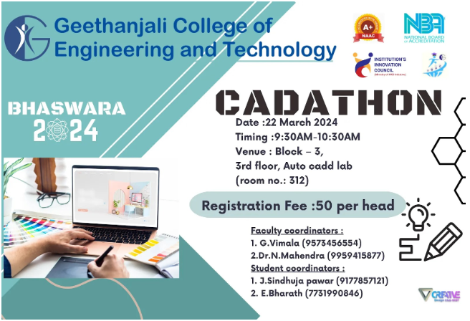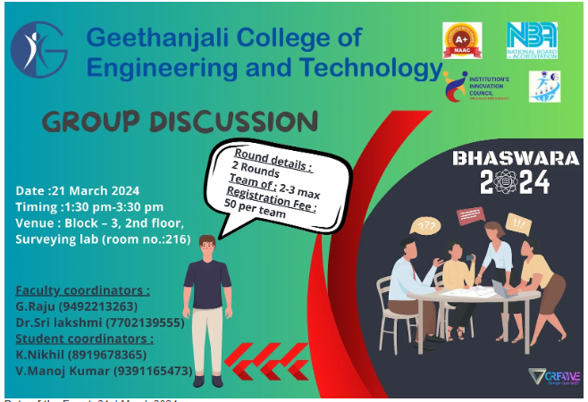
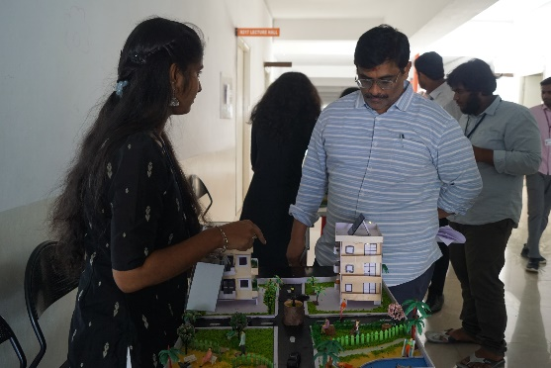
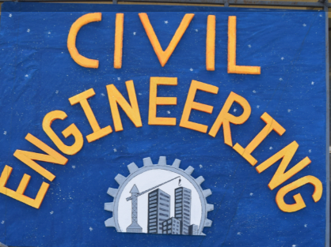
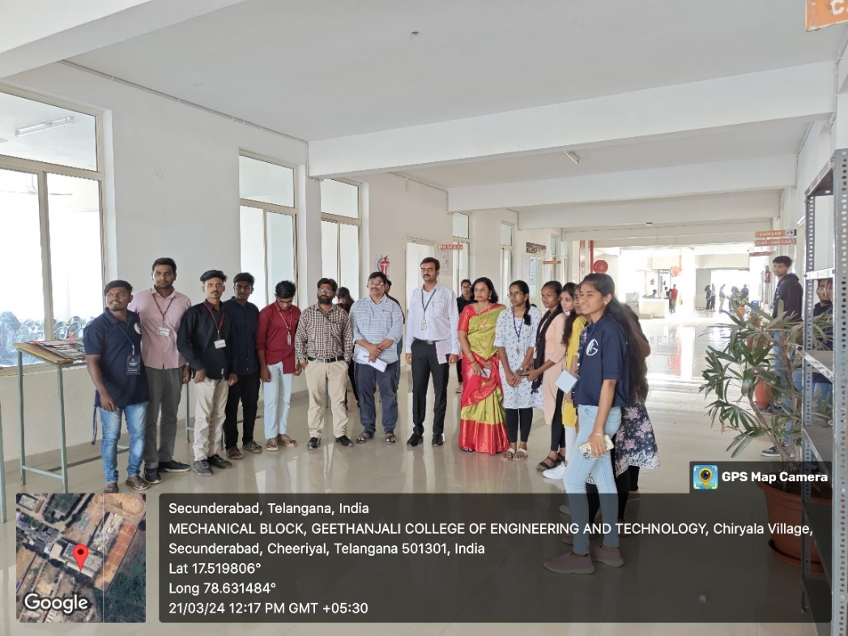
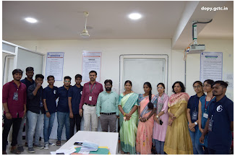

Freshers Day

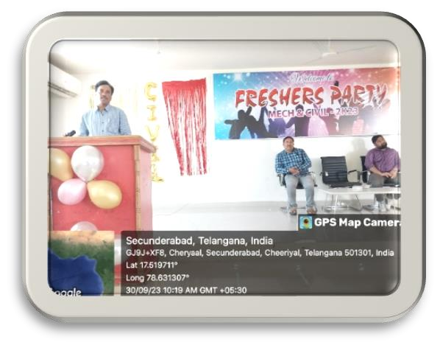
A.Y. 2023-2024
On September 30, 2023, the Civil and Mechanical Engineering departments at GCET hosted a Freshers' Day in the Block 3 Seminar Hall. The event started with welcoming speeches by the heads of both departments, followed by engaging activities, including games and cultural performances by senior students. Freshers introduced themselves and interacted with peers and seniors. The evening ended with a vote of thanks and refreshments, making the event a warm and memorable welcome for the new students.

Alumni Interactive Session:
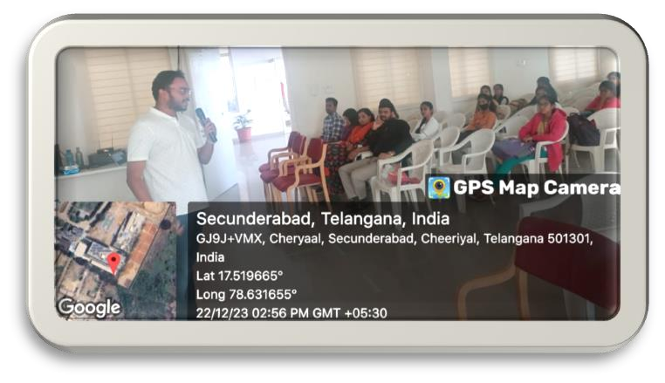
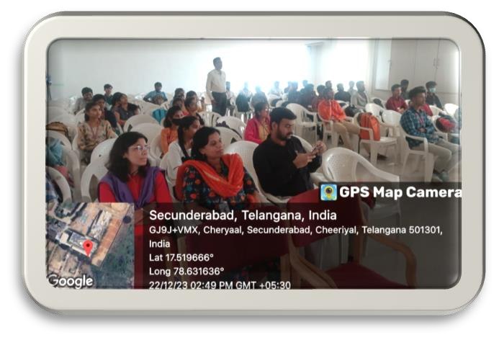
GCET alumni organized an interactive session with Ch. Vedamitra, a former TCS employee currently pursuing an MBA at IIT Bombay. Vedamitra shared his career journey, insights into the corporate world, and the benefits of higher education. The session included a Q&A segment where students asked questions about career growth and industry trends. The event was well-received, providing valuable guidance and fostering a strong connection between students and alumni.

Training Program on “REVIT-Architecture”, “Revit Structures” and “Sketch- UP”
The Civil Engineering Department, in collaboration with CANTER CADD, organized a comprehensive training program on “REVIT-Architecture,” “Revit Structures,” and “SketchUp” during the academic year 2023-24. This initiative successfully benefited around 80 students, providing them with valuable skills and knowledge in these advanced design and modelling tools.

